INSTRUCTIONS FOR USING MY PROGRAMS

Here is the full code of the program to detect a failure :
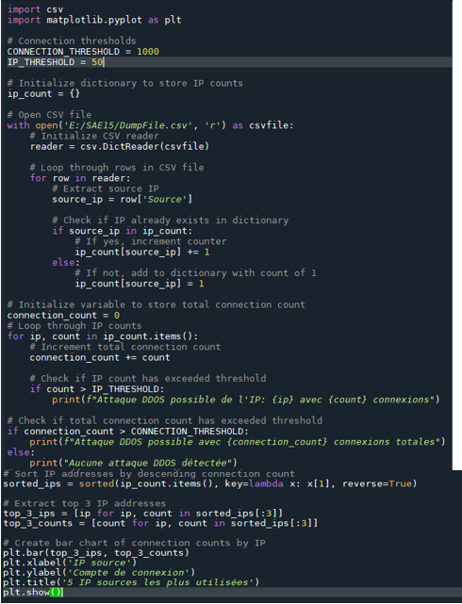

Let’s now turn to the instructions for using this program :
General description : This Python code uses a CSV file processing library to read a file that contains the frame data. This program will therefore count connections from each IP address and detect potential DDOS attacks. It also uses the Matplotlib library to create a bar graph of the most used IP addresses that send the most packets.
Prerequisites : To use this code, you must have Python installed on your computer or software like Spyder as well as CSV and matplotlib libraries.
Installation : Make sure you have installed the necessary libraries using the following commands :
- Pip install csv
- Pip install matplotlib
Also change the CSV file path in the line “with open(‘E:/SAE15/DumpFile.csv’, ‘r’) as csvfile:” to match the file location on your computer
Use :
- Run the code using the python command filename.py or run it on a software like Spyder
- The code will read the CSV file, count connections from each IP address and detect potential DDOS attacks using the connection and IP thresholds defined in the CONNECTION_THRESHOLD and IP_THRESHOLD variables. Results will be displayed on the screen
- The code will also create a bar graph of the most used IP addresses with the 3 most used IP addresses
Common Errors:
If the CSV file path is incorrect, the code will generate a “FileNotFoundError” error Make sure the path is correct
If the necessary libraries are not installed, the code will generate an “ModuleNotFoundError” error. Make sure you have the necessary libraries installed.
Here is the full code of the program allowing to open the file in CSV and thus to sort correctly and have the readable information.

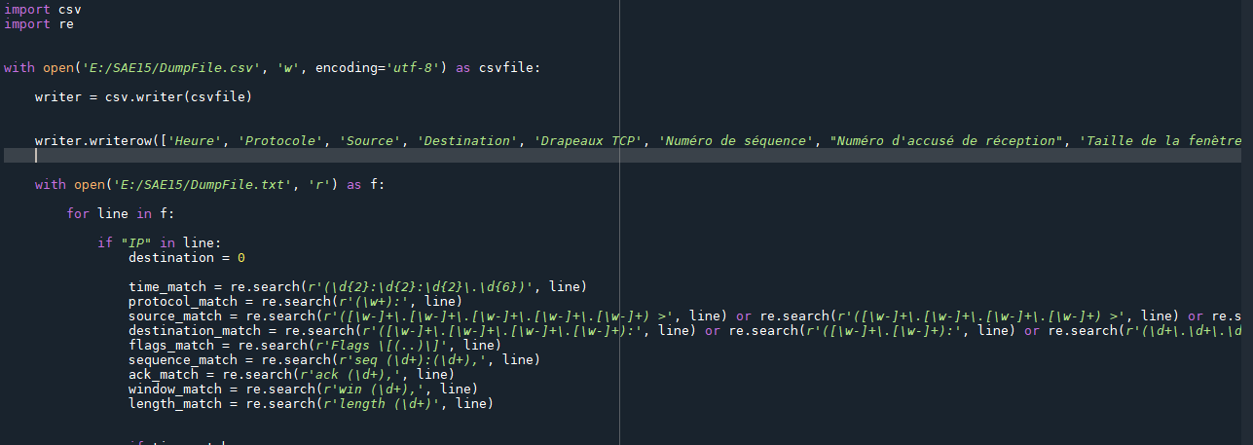
Here is the full code of the program allowing to open the file in CSV and thus to sort correctly and have the readable information.

The three lines that are not displayed in full are :
writer.writerow(['Time', 'Protocol', 'Source', 'Destination', 'TCP Flags', 'Sequence Number', "Acknowledgement Number", 'Receive Window Size', 'Length'])
source_match = re.search(r'([\w-]+\.[\w-]+\.[\w-]+\.[\w-]+\.[\w-]+) >', line) or re.search(r'([\w-]+\.[\w-]+\.[\w-]+\.[\w-]+) >', line) or re.search(r'([\w-]+\.[\w-]+) >', line) or re.search(r'(\d+\.\d+\.\d+\.\d+) >', line)
destination_match = re.search(r'([\w-]+\.[\w-]+\.[\w-]+\.[\w-]+):', line) or re.search(r'([\w-]+\.[\w-]+):', line) or re.search(r'(\d+\.\d+\.\d+\.\d+) :', line)
The rest of the program :
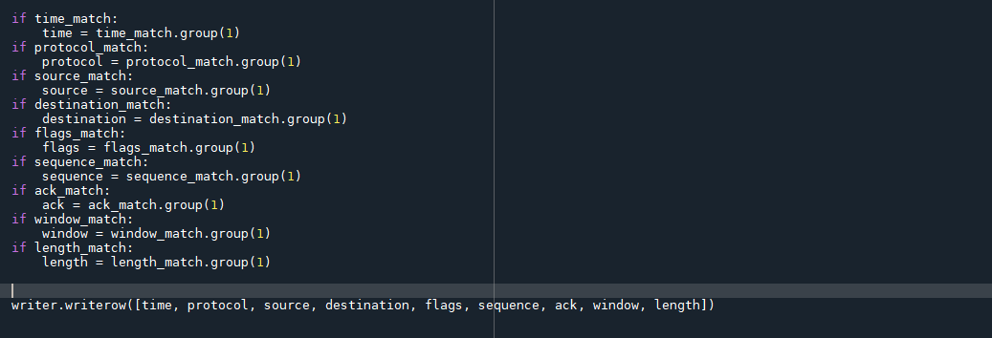
Let’s now turn to the instructions for using this program :
General Description : This program uses the Python csv and re modules to extract information from a file that contains frame data (DumpFile.txt) and write it to a CSV file (DumpFile.csv). It uses regular expressions to extract the desired information from each line of the frame data file
Prerequisites : To use this program, you must have Python installed on your computer or a software such as Spyder, as well as the csv module and the re module
Installation :
Ensure that the csv and re modules are installed on your computer using the following commands :
- Pip install csv
- Pip install re
Change the access paths for the DumpFile.txt and DumpFile.csv files in the lines "with open('E:/SAE15/DumpFile.txt', 'r') as f:" and "with open('E:/SAE15/DumpFile.csv', 'w', encoding='utf-8') as csvfile" to match the location of the files on your computer
Use :
- Run the program using a Python interpreter or software such as Spyder, Visual Studio Code
- The program will open the file DumpFile.txt in play, browse each line and use regular expressions to extract the desired information

